### pName: ____________________________________

| Exam 2 – Spring 2018 | |
| --- | --- |
| Course Information: Phys 2B | Instructor Name: John R. Walkup |

***d*** = ***v***o*t* + (1/2)***a****t*2 ***v*** = ***v***o + ***a****t*  ***F***net = *m****a*** ***F***g = *m***g** *V* = *kQ*1*/r  V* = *Ed R = L/A*

*k =* 9 X 109(SI units) *WC = –*PE *WNC =* E *Wnet =* 😐E *W* = *Fd*cos     😐  *mv*2

*E* = *kQ/r*2 PE = *kQ*1*Q*2*/r V = IR C = k*o*A/d C = Q/V e =* 1.6 X 10-19 *C B =* *oNI/(2**r)*

o*=*4 *X 10-7* (SI units) *F* = *qvB*sin *F = BIL*sin micro () means 10-6 Use *g* = 10 m/s2

#### Multiple Choice Questions

1. A positive charge is forced to move from a negatively charged plate toward a positively charged plate by an external nonconservative force.
2. Its potential energy and total energy both increase.
3. Its potential energy and total energy both decrease.
4. Its potential energy increases; its total energy stays the same.
5. Its potential energy decreases; its total energy stays the same.
6. Its potential energy increases; its total energy decreases.

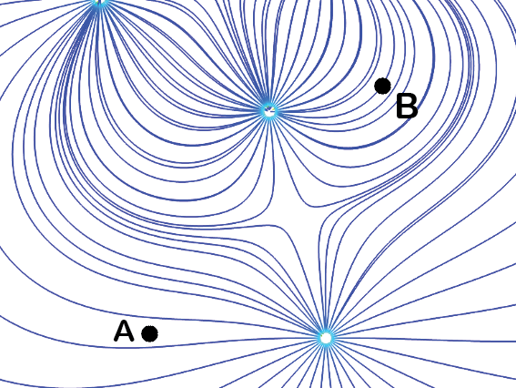

1. In the figure is shown an electric field. Which is true of the electric field at point A.
2. It points horizontally and is much stronger than at Point B.
3. It points vertically and is much stronger than at Point B.
4. It points horizontally and is much weaker than at Point B.
5. It points vertically and is much weaker than at Point B.
6. There is no electric field at Point A because no electric field line passes through Point A.
7. 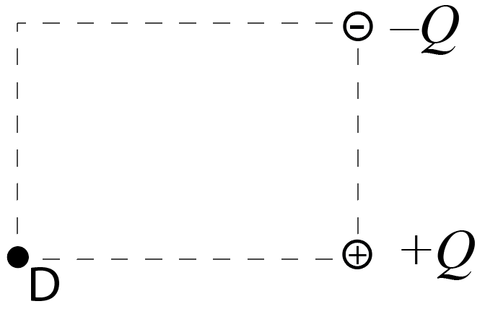The electric field at point D will point in which direction? (Both charges have the same magnitude.)
8. Toward the bottom right
9. Toward the upper left.
10. Toward the upper right.
11. Toward the bottom left
12. The electric field is 0.
13. Voltage is defined as
14. The difference in potential energy between two points.
15. The difference in Coulombic force between two points.
16. The difference in electric field strength between two points.
17. The difference in potential between two points.
18. None of the above.
19. Which of the following is correct?
20. Electric field lines are directed perpendicular to an insulator, but not necessarily a conductor.
21. Electric fields are never directed perpendicular to surface, whether it is an insulator or conductor.
22. Electric field lines are always directed perpendicular to a surface, whether it is a conductor or insulator.
23. Electric fields are directed perpendicular to a conducting surface, but not necessarily an insulator.
24. None of the above.
25. An electron is forced to move from a positively charged plate toward a negatively charged plate by an external nonconservative force.
26. Its potential energy and total energy both increase.
27. Its potential energy and total energy both decrease.
28. Its potential energy increases; its total energy stays the same.
29. Its potential energy decreases; its total energy stays the same.
30. 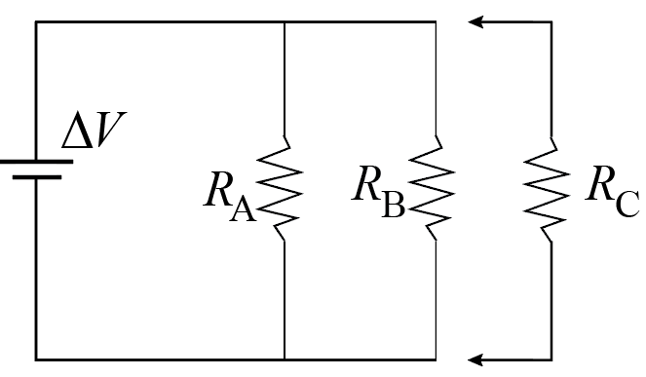 Its potential energy increases; its total energy decreases.
31. In the figure, I place an extra resistor RC in parallel with the resisters in the circuit. (The battery has no internal resistance.) The current passing through RA (the resistor on the far left) will
32. Rise if RC > RA but drop if RC < RA
33. Drop if RC > RA but rise if RC < RA
34. Drop
35. Rise
36. Stay the same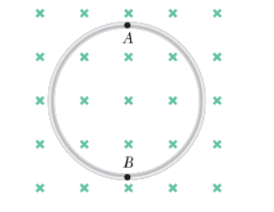
37. 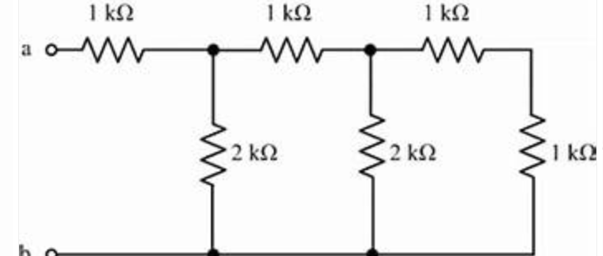Find the equivalent resistance of the circuit shown in the figure.
38. 3.5 
39. 6 
40. 8 
41. 2 
42. 3.3 
43. A loop of wire is placed in a magnetic field point. The magnetic field points into your paper. All of a sudden, we compress the wire to make a smaller circle. During this time, in which direction is the induced current? (Ignore Points A and B.)
44. Clockwise.
45. Counterclockwise.
46. There is no current because there is no magnetic flux penetrating the loop.
47. There is no current because the magnetic flux is not changing with time.
48. The current will initially flow clockwise, then reverse direction.
49. The flexible single loop of wire in the figure on the right has a radius of 20 cm and is in a magnetic field of strength 0.2 T. The wire is made of material having a total resistance of 12 . The loop is grasped at points A and B and stretched until its area doubles. If it takes 0.4 s to close the loop, what is the magnitude of the average induced current in it during this time?
50. 0
51. 0.1256 A
52. 0.0026 A
53. 0.0083 A
54. 0.0104 A
55. 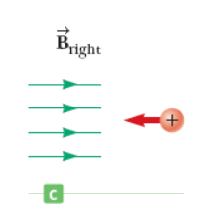Determine the initial direction of the deflection of the charged particle as it enters the magnetic fields as shown in the figure below.
56. Into the paper (away from you)
57. Upward
58. Downward
59. Out of the paper (towards you)
60. There is no deflection

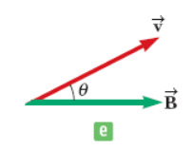

1. Find the direction of the force on a proton (a positively charged particle) moving through the magnetic fields in the figure, as shown
2. Into the paper (away from you)
3. Toward the upper left
4. Toward the lower right
5. Out of the paper (towards you)
6. None
7. The magnetic field 35.5 cm away from a long, straight wire carrying current 1.90 A is 1.07 μT. At what distance is it 0.107 μT? (NOTE: This is one of the tougher questions. I suggest you do it last.)
8. 5.22 m
9. 3.55 m
10. 4.08 m
11. 1.88 m
12. 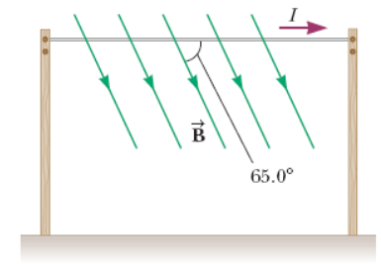1.12 m
13. A power line of length 50 m carries a current of 2.3 kA as shown in the figure. Earth's magnetic field at this location has a magnitude equal to 5.0 ✕ 10−5 T and makes an angle of 65° with the power line. Find the magnitude of the magnetic force on the power line.   
    Note: cos(65o) = 0.423; sin(65o) = 0.906; tan(65o) = 2.14.
14. 8.34 T
15. 7.15 T
16. 9.82 T
17. 6.73 T
18. 5.21 T
19. For the previous problem, which direction is the forced directed?
20. Into the paper (away from you)
21. Toward the upper left
22. Toward the lower right
23. Out of the paper (towards you)
24. 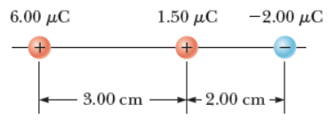Toward the upper right
25. Determine the electric field strength at a point 1.00 cm to the left of the middle charge shown in the figure below.
26. 2.0 ✕ 107 N/C
27. 3.4 ✕ 107 N/C
28. 1.8 ✕ 107 N/C
29. 4.6 ✕ 107 N/C
30. 2.8 ✕ 107 N/C

#### Name: ____________________________________________

***d*** = ***v***o*t* + (1/2)***a****t*2 ***v*** = ***v***o + ***a****t*  ***F***net = *m****a*** ***F***g = *m***g** *V* = *kQ*1*/r  V* = *Ed R = L/A*

*k =* 9 X 109(SI units) *WC = –*PE *WNC =* E *Wnet =* 😐E *W* = *Fd*cos     😐  *mv*2

*E* = *kQ/r*2 PE = *kQ*1*Q*2*/r V = IR C = k*o*A/d C = Q/V e =* 1.6 X 10-19 *C B =* *oNI/(2**r)*

o*=*4 *X 10-7* (SI units) *F* = *qvB*sin *F = BIL*sin Use *g* = 10 m/s2

#### Free Response Questions

1. Two wires separated by 2 meters are carrying current in the same direction. One carries a current of 2 amps and the other carries a current of 3 amps. For the following, show all work starting with the equations at the top of the first page and/or explain your reasoning. Do NOT simply write down a formula specifically derived for this problem.
2. Find the force on the wire carrying the 3-amp current. In which direction does it point?
3. Find the force on the wire carrying the 2-amp current. In which direction does it point?
4. Will the wires attract each other or repel?

1. In the figure is a fairly complex circuit. Write down the sum of voltage drops that you would get if you apply Kirchhoff’s Rules to the circuit. Be sure to include the current junction rules. NOTE: You do not have to solve the system of equations to receive full credit.

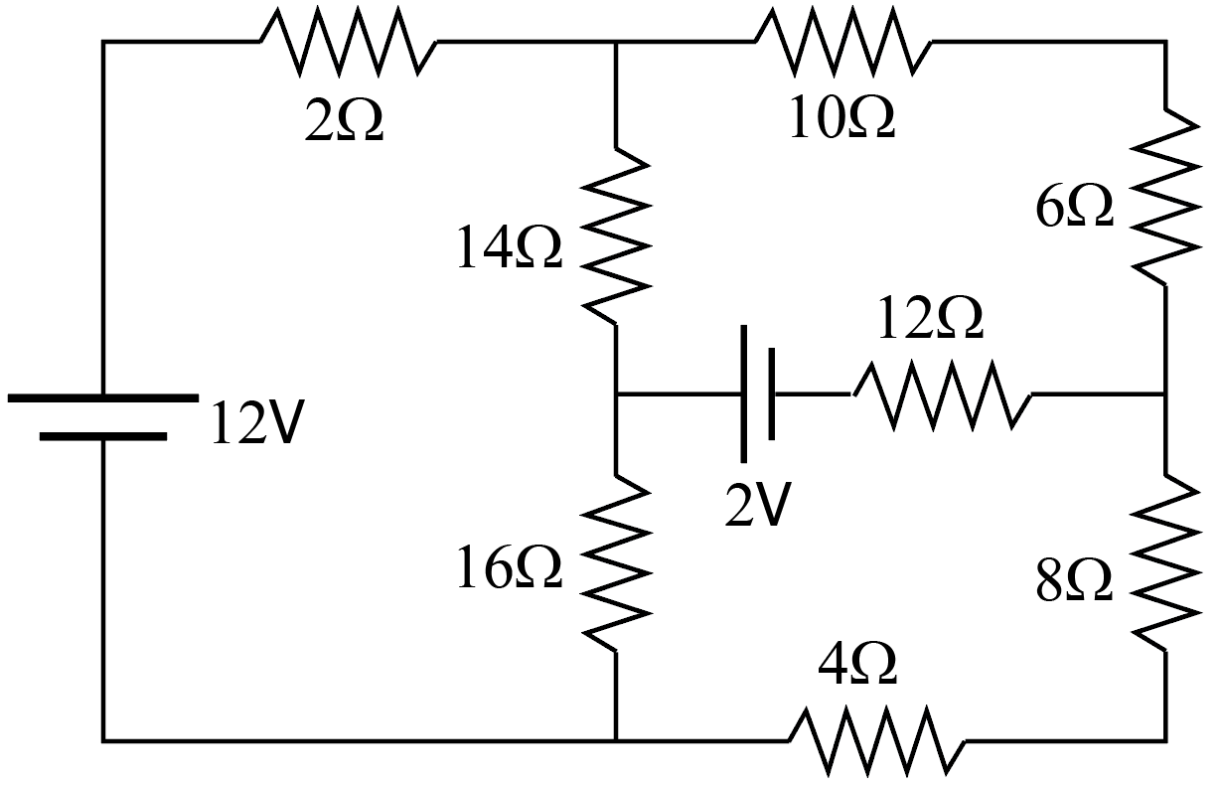

1. Four long, parallel conductors carry equal currents of *I* = 3.10 A. The figure shown below is an end view of the conductors. The direction of the current is into the page at points A and B (indicated by the crosses) and out of the page at C and D (indicated by the dots). Calculate the magnitude and direction of the magnetic field at point P, located at the center of the square with edge of length 0.200 m.

